Ornaments as indicators of Social change before and after European contact at Kiwulan, Northeastern Taiwan

Li-Ying Wang

Ben Marwick

09 July, 2019

Text of abstract

# Introduction

Taiwan had been involved in regional exchange network of East Asia and Southeast Asia since the tenth century and became part of a global trade systmes during the early 17th century due to western European expansion that connected European and Asia (Liu and Wang, 2017). Compared to other places in Asia and Oceania, the impact of European colonialism on indigenous communities in East Asia appears to have been much less pronounced. Direct colonial rule was rare and limited, but the question of long-lasting indirect impacts on local indigenous communities remains unanswered. Indirect effects of colonialism is emphasized increasingly to discuss the colonial impact on the indigenous people in the periphery of colonial control (Torrence and Clarke, 2000; Trabert, 2017). In many parts of the world, foreign trade goods introduced into local indigenous societies in a colonial or imperial contexts might cause significant transformations of indigenous economic, cultural, and socio-political systems (Dietler, 1997; Junker, 1993; Mitchell, 2000; Silliman, 2005). Contrary to as passive receptors of imperial power, the agency of indigenous people in the colonial contexts has been broadly discussed to emphasize the ability of active adoptions of foreign effects, negotiation between colonized and colonizer, and resistance of indigenous people through daily cultural practices (Dietler, 2015; Given, 2004; Rubertone, 2000; Silliman, 2001; Torrence, 2000; Torrence and Clarke, 2000; Voss, 2005). Studying the consumption of foreign goods is one way to understand indigenous experience of the colonial encounter and explore the agency of indigenous people by examining how those goods were distributed and used when obtained (Dietler, 2005; Mullins, 2011; Scaramelli and Scaramelli, 2005).

Despite colonization of Taiwan by the Spanish and Dutch from 1624 to 1662, little had been discussed in archaeology about the reaction of indigenous people to the European colonization. Berrocal et al. (2018) study the long-term record of Heping Dao in northern Taiwan and explore the effects of European colonization on the local populations by focusing on the environmental change and introduction of diseases, with a little mention of indigenous social complexity. Northeastern Taiwan, Yilan, is an especially unique example for exploring indirect effects due to its physically isolated location that made it not easily accessible to the Europeans and the colonial control was less compared to other parts of this region (Andrade, 2007; Kang, 2012). Although the location is relatively peripheral, the sea provides a way through which indigenous people could interact with other groups from different regions, including other native indigenous groups, foreign traders such as the Han people of China, and Europeans. Large-scale and frequent trade activities brought a wide variety of trade objects into indigenous communities in Yilan through local regional exchange network. Among those trade goods, ornament such as glass and stone beads was one of the common foreign goods found at the settlement sites in this region (Chen, 2007; Li and Chiu, 2014; National Musuem of Taiwan History, 2005). Body adornment is usually viewed as a signal in indigenous social life to represent and reinforce their status through the body as the scene to display (Joyce, 2005; Scaramelli and Scaramelli, 2005). For example, the consumption of stone beads in Southeast Asia during Iron Age were usually associated with increasing social stratification or socio-political complexity (Bellina, 2014; Carter, 2016; Francis, 2002; Theunissen et al., 2000).

In this paper, I explore the evidence from a site spanning from late Iron Age to historical period by addressing the question of whether colonial influence on indigenous populations can be detected in ornaments recovered from the archaeological record at Kiwulan (1400-1900 AD), a large Iron Age settlement in northeastern Taiwan (Chen, 2007). Prior to the contact with the Europeans in the early 17th century, northern Taiwan had been involved in both regional and long-distance East and Southeast Asian trade systems, and later encountered a large wave of Han Chinese migration in the 19th century (Chen, 2005). As Lape (2003) points out based on case studies in island Southeast Asia, the study of multiple episodes of culture contact has potential to expand our understanding of the causes and effects of culture contact both locally and worldwide. Northeastern Taiwan provides a good example to explore the indirect impacts on indigenous societies by comparing archaeological evidence from different episodes of culture contact based on a long-term perspective. The variety and cultural context of trade ornaments will be reviewed, and their capacity to inform on how the distribution of ornaments reflect social changes will be examined. I hypothesize that there was a greater diversity of ornaments types and materials at Kiwulan after European contact due to the large scale exchange network, and the consumption of ornaments present some spatial pattern that indicates increasing social inequality. I hypothesize that after Chinese contact there was a decline in the production, use and discard of ornaments at Kiwulan.

# Cultural context of ornaments in northeastern Taiwan, Yilan

Prior to European colonization, the indigenous people in northern Taiwan had already established their own exchange network that defined as “inter-insular trade” by Chen (2005, p. 12) to refer to small-scale regional trade between China and Taiwan on irregular basis. This local exchange network of northeastern Taiwan had increasingly influenced by long distance trade between Fuzhou or Quanzhou in China and Ryukyu in Japan since 15th century due to its location on the shipping routes, and was intensified in the 17th century when the arrival of the Europeans and their trade goods (Chen, 2005; Liu and Wang, 2017; Wang and Liu, 2007). Despite being on the periphery of major trade ports, Keelung and Tanshui, in northern Taiwan, Yilan was involved in this network through the periodic exchange activities between different indigenous groups. Yilan, also called “Kavalan” by local indigenous people since the prehistoric time, is a alluvial plain circumscribed by the Pacific and mountains on the sides. Rivers and seas provide the way for the interaction between local indigenous people and another native group called Basai in northern Taiwan and Han Chinese. Kavalan people offered rice, deer hides, and gold in exchange for beads, metal tools or ornaments, ironwares, porcelains, and textiles with outside traders (Chen, 2005; Hsieh, 2009; Li and Wu, 2006).

Historical documents from the Spanish and Dutch in the early 17th century provide some information about the social life and culture of indigenous people in Northern Taiwan when the Europeans arrived. The Spanish founded Fort San Salvador at Keelung in 1626 and Fort San Domingo in 1629 at Tamsui, and sent missionaries to local indigenous settlements in this region for religious purpose (Blussé and Everts, 2000, p. 343). The report of the Dominican priest Fr. Jacinto Esquivel in 1632 mentioned that the Taparri, an indigenous tribe from northern Taiwan, usually used cuentas (agate beads) in exchange for necessities with other indigenous group. This form of exchange spread widely and even the Spanish soldiers learned to use agate as bargaining chips for gambling, since agate equaled money (Li and Wu, 2006, pp. 132–149). Father Jacinto Esquivel also recorded how indigenous viewed it as prestige goods in their culture. A indigenous male who wanted to get married had to pay agate beads to the parents of his future wife. Also, agate or golden beads could be used as to solve conflicts in their daily lives (Li and Wu, 2006, p. 151). Other records mention that the female shamans (majuorbol) in the tribe would use agate beads as magical items in ritual practice for body healing(Borao, 2009, pp. 122–151). A funeral process in indigenous culture was recorded about how agate beads used commonly in ritual contexts, where more agate beads, pottery and cloths were be placed into the grave of more influential people to indicate a family’s prestige (Li and Wu, 2006, p. 153).

Those documents indicate that agate beads or golden beads were already treated as prestige goods before the arrival of the Europeans, that is believed to be introduced earlier from Chinese traders. In 1642, the Dutch VOC defeated the Spanish and take over the northern Taiwan. They introduced feudal symbolism in an attempt to control the indigenous communities by asking indigenous leaders to attend annual ceremony for feudal practices (Andrade, 2007, ch. 9; Kang, 2016, ch. 4). More beads entered indigenous settlements through the gift-giving that the Dutch provided goods based on the demand of native people to secure indigenous alliances in the annual ceremony or on the way of traveling (Kang, 2016, ch. 6). Thus, I assume that the way of gift giving resulted in an increase in the amount and diversity of ornaments in northeastern indigenous communities within existing consumer contexts during this period.

The documents written by Chinese historians in Qing dynasty usually described the decorative purposes of the ornaments and some documents had similar texts that might be copied from previous ones without actual investigation. According to those records, indigenous people in Yilan had a custom to wear ornaments in ceremonial contexts to display their wealth and status (Chen, n.d., pp. 228, 308; Ke, n.d., pp. 11, 126; Yao, n.d., p. 77). Among those ornaments, golden fish-shaped necklaces made of copper threads had higher value due to its delicacy and more materials invested in production that usually possessed by rich people. Other people wore agate beads or glass beads on their head or neck to participating various ceremonies. In 1895, at the beginning of Japanese colonization, (**???**) conducted a field survey for several aboriginal groups and found that golden necklaces had not been used in Yilan that time, but elder people still used beads.

Recent ethnographic research of the Kavalan tribe describes that agate beads were used in divination practice, called “subli”, by female shamans (Liu, 2008, pp. 133–134). Interview records mention agate bead is valuable object that are usually passed down from mother to daughter as a heirloom in shaman families without knowing the exact origin. Were not been using, beads would be often hided at invisible place such as on the roof beams to make sure no one sees that. Modern ethnographic research shows that agate beads were not only used as decoration, but also played an important role in divination that is consistent with the observation in European colonial period. It was usually the female shamans conducting divination ritual that passed down from their ancestors. Despite most aborigines today don’t know the origin of agate beads, the value of beads is still be highlighted through oral history and their scarcity. Those historical documents from the early 17th century to the modern ethnography described how local indigenous people use ornaments in local cultural contexts that represents some social roles or status. However, compared to European contact period, there is less mention of beads in Chinese contact period and the description about ornaments is only limited to their dressing culture.

# Kiwulan in northeastern Taiwan

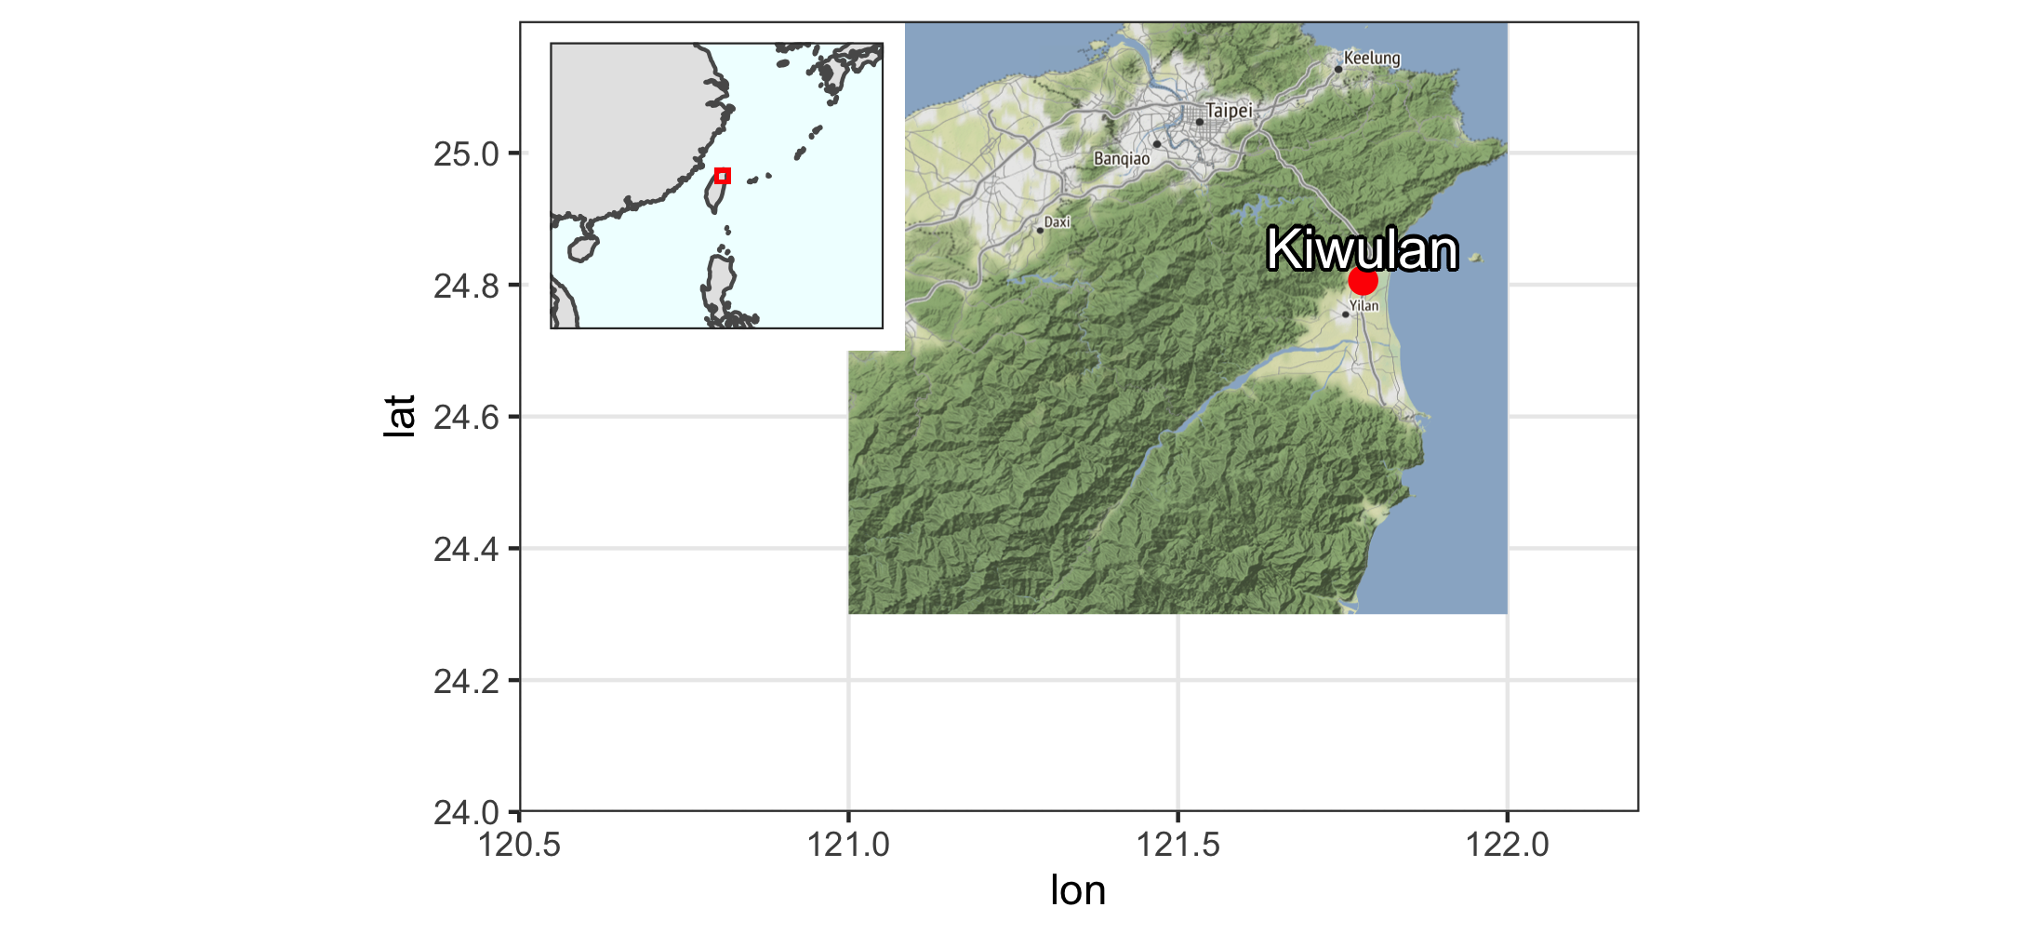

Figure 1: Kiwulan location in Southeast Asia

Kiwulan 1 is located at northern Yilan and was a rescue archaeology projects that carried out from 2001 to 2004 in advance of construction. The total area includes eight open area sections that created 262 squares (4m by 4m) reaching 3,814 meter squares in total (Chen, 2007). Most ornaments were found in situ in the context while digging and some were collected through screens with 2 mm and 1.5 mm mesh. The archaeological evidence includes a rich amount of artifacts, burials, middens, post holes, wooden pillars, and stone structures that indicates it was a settlement. The chronology of Kiwulan can be divided into Lower Layer Culture (700 - 1200 AD) and Upper Layer Culture (1400 - 1900 AD) with a sterile layer in between based on a series of 32 radiocarbon dates (Chen, 2007). This paper focuses on the Upper Layer Culture spanning from the late Iron Age that also called proto-historical period (Liu and Wang, 2017), and historical period starting from the 17th century with European contact in Taiwan.

The earliest record of direct European contact with indigenous people in Yilan can be traced back to 1632, when the local villages were attacked by the Spanish who took revenge on an incident happened earlier that year (Borao, 2001, p. 163). Later in 1647, the Dutch attacked the indigenous villages and forced them to accept colonial rules and economic demands by paying annual tribute (Andrade, 2007). According to Dutch census reports in 1650, Kiwulan was the largest indigenous settlement in the Yilan Plain, with a population of 840 adults (Nakamura, 1938, p. 12). The diagnostic artifacts of European contact found at Kiwulan including An-ping jars, stonewares that were largely introduced to Taiwan during the early 17th century. Those artifacts coupled with the original radiocarbon dates were used to identify the pre-European and post-European periods. The European colonization ended in 1662 when they were defeated by the kingdom of Tungning found by Koxinga from China. Later in 1683, the Qing dynasty ruled over Taiwan and a large wave of Han Chinese migrated to Yilan during the late 18th century. The evidence of Chinese migration can be identified both from Chinese official records and large amount of Chinese daily life porcelains found at Kiwulan (Chen, n.d.).

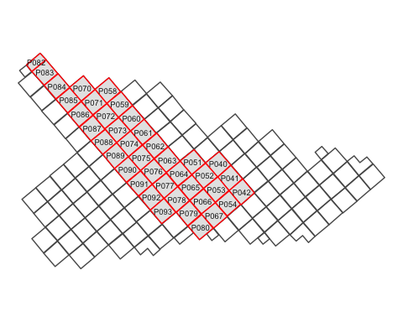

Figure 2: Forty squares were sampled from the largest open area (in red with square ID number)

The ornaments studied in this paper found from 40 adjacent square of the largest open area that was located in the middle part of excavation (Figure 2. They were sampled because those units were more stratigraphically intact with the least disturbance by modern constructions. The Upper Layer Culture component could be divided into six sub contexts spanning from 14 century to 19 century with a hundred year interval according to original radiocarbon dates, excavation depth, and types of diagnostic porcelain (Hsieh, 2009; Wang, 2011). The contexts were assigned numbers from 1 to 6 where L1 corresponds to the youngest context and L6, the bottom layer, refers to the oldest context. To obtain a more reliable chronology for comparison between episodes of culture contact,I reevaluate those contexts for each sampled square by focusing on Anping jars and stonewares that are believed manufactured and distributed in Southeast Asia through European trade route during the early 17th century (Ketel, 2011). Those two categories of ceramic coupled with radiocarbon dates were used to identify the pre-European and post-European periods. Following the previous numbering principle, I separated three episodes of time including pre-European contact period(L5, L6), European contact period(L4), and Chinese contact period (L2 and L1).

In general, complete ornaments with clear context were mostly found in burials that helps to understand how people wear them. In addition to burials, large amount of ornaments were found at household area that were identified by a series of post holes across the space. Here I focus on the ornaments found at post-hole area considering the overall quantity and the comparison across the space. Ornaments were made from a wide variety of raw materials, in which glass, agate and copper are the common materials that were thought to be introduced through trading with the Europeans and Chinese traders since no clear evidence of waste by-products in the archaeological record (Chen, 2007). Although a possibility of small workshops that individuals were able to produce golden beads from prepared glass materials by heating (Cheng, 2008), no evidence of accompanying tools or materials in proportion to the large amount of golden beads were found. The shape of ornaments include beads, bracelets, rings, bells, pendants, and knitted objects. It shows that the shape is closely related to what kind of raw material it was made from. For example, beads were only made of glass and agate, while copper ornaments were in the form such as bells, bracelets, and rings (Chen, 2007).

# Samples and Methods

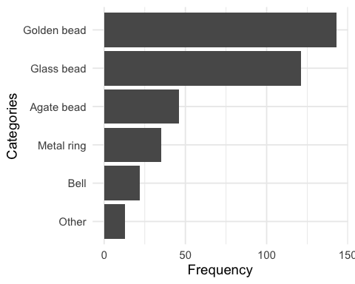

Figure 3: Frequency of ornaments

Table 1: A table of ornament subtypes

|  |  |  |  |  |
| --- | --- | --- | --- | --- |
| Categories | Type | Before European Contact | European Contact | Chinese Contact |
| Agate bead | hexagonal | 6 | 17 | 5 |
| Agate bead | waxy oval | 0 | 4 | 0 |
| Agate bead | small oval | 3 | 3 | 0 |
| Agate bead | globular | 0 | 1 | 0 |
| Agate bead | pentagonal | 0 | 1 | 0 |
| Agate bead | big oval | 0 | 0 | 1 |
| Agate bead | long bicone | 0 | 0 | 1 |
| Agate bead | octagonal | 0 | 0 | 1 |
| Bell | large | 3 | 8 | 3 |
| Bell | plain small | 0 | 4 | 1 |
| Bell | thin small | 0 | 1 | 1 |
| Glass bead | small bead | 60 | 37 | 1 |
| Glass bead | medium bead | 8 | 15 | 0 |
| Golden bead | NA | 48 | 93 | 2 |
| Metal ring | wide small | 1 | 9 | 1 |
| Metal ring | thin large | 4 | 5 | 2 |
| Metal ring | wide large | 0 | 5 | 0 |
| Metal ring | overlapped | 0 | 2 | 0 |
| Metal ring | braid | 0 | 1 | 0 |
| Metal ring | entwined | 1 | 1 | 0 |
| Metal ring | flat | 0 | 1 | 0 |
| Metal ring | large thick string | 0 | 1 | 0 |
| Metal ring | small thin string | 0 | 1 | 0 |



Figure 4: Subtypes of ornament in each major category. A: agate beads, B: bells, C: glass beads and golden beads, D: metal rings. Photographs are presented in the same order as those subtypes in the table but from left to right instead. The photographs of B, C, D categories were from original excavation report.

To explore whether body ornaments can reflect the colonial influences on indigenous populations, this paper examines the variety, frequency, and spatial distribution of trade ornaments across different time periods, including pre-European contact, European contact, and Chinese contact. Those three analytic units could represent three scales of exchange network from small to large, and three degree of contact from weak to intense. Because the appearance of ornaments is highly related to the original raw material, the type of raw material is the first criterion of classification that determined five major categories. In each category, ornaments were classified into several subtype according to their shapes when variations were present in each category. The variation was defined by the difference identified in at least two variables, for example dimensional variables such as length, or stylish variables such as patterns. In order to compare the general pattern of changes for subtypes, less frequent subtypes were left out from the analysis, but will be discussed separately in later section.

Ornaments from the post-hole area accounts for the majority of the amount in total. Post-hole area provides a clear contexts and basis for comparison to see if there is any spatial pattern of distribution. For the post-hole area, there were 406 ornaments recovered from the 40 sampling squares, which accounts for 0.5% of the total number of ornaments found in the same open area section. Figure 3 shows that the most common ornament is golden bead with the number of 143, followed by 121 glass beads, 46 agate beads, 35 metal rings, and 22 metal bells. The variety of subtype and their individual frequency are summarized in 1 in terms of three time episodes. The image for each subtype in major category shows in figure 4.

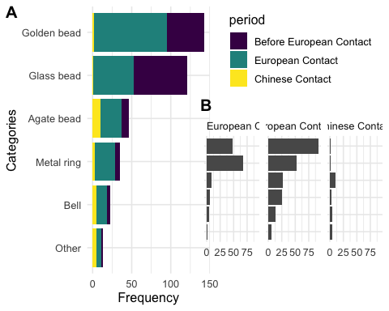

# Results

## Frequency between time periods

The results of the comparison between different time periods show a general pattern that most ornaments existed already before European contact and the frequencies reached a peak during the European contact and then dropped during the Chinese contact period, especially for golden beads. This trend can be also seen on other ornaments including agate bead, metal ring, and bell. However, glass beads show a different pattern that indicates a higher frequency in the pre-European contact, and then the frequency decreased in the European contact period and even much less in the Chinese contact period.

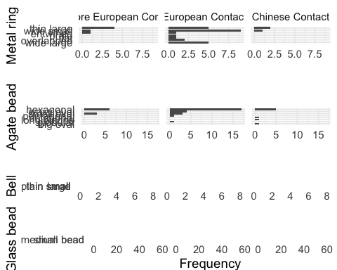

Figure 5: Frequency of

The distribution of frequency for subtypes in each major category are presented in 3. The distribution shows that agate beads and metal rings have greater quantity and variety of shapes compared to copper bell and glass beads during the European contact period. Agate beads can be divided into seven subtypes, in which hexagonal shape is the most common subtype that appeared before European contact and increased significantly during the European contact and then declined in the Chinese contact. Small oval type shows similar frequency before and during European contact but not found in the Chinese contact period, while waxy oval bead only found during European contact period. Higher variety of agate beads were found in European contact compared to other time periods. Similarly, metal rings can be classified into eight subtypes, in which wide small ring is the most common metal ornaments, followed by wide large and thin large shape. The greater varieties for those two categories might indicate the multiple origins due to global trade network stimulated by the Europeans. In contrast, copper bell and glass bead have less variety, but glass bead has larger number due to they were usually found in a cluster that indicates the original use as strings or necklaces. The common shape for copper bell is the large shape with a wide variety of human face as a motif, while the common shape for glass bead is bead with length less than 1cm that are identified as Indo-Pacific beads, the most common type that had been widespread in Southeast Asian sites since 300 BC (Francis, 2002).

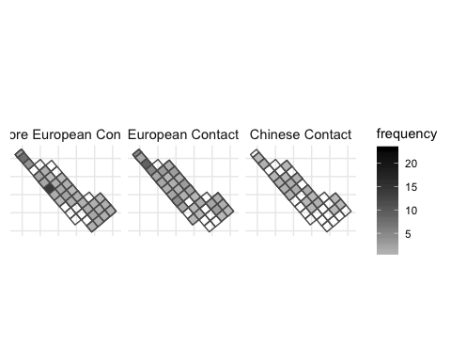

Figure 6: Spatial pattern of ornaments

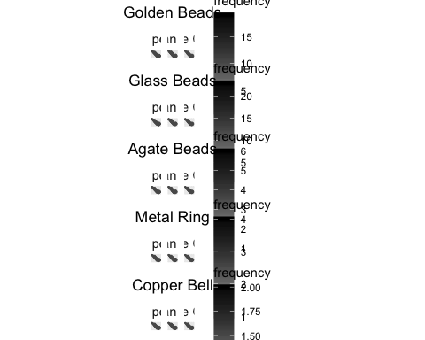

## Frequency for spatial pattern

Figure 6 presents the spatial distribution of all categories for each time period. It shows that one square unearthed more ornaments than others in the pre-European contact. During the European contact period, ornaments was more ubiquitous with some clusters on northern part, and less presence during the Chinese contact period. When looking at the distribution for each major class individually, some clusters across the area were observed during the European contact including golden bead, agate bead, metal ring, and bell. However, it seems no clear consistent clustered pattern across those different ornaments. Each class shows its own pattern where the squares with higher number of ornaments distributed separately and independently. For example, the cluster of golden bead were found at the northern part, while the cluster of agate bead were found in the middle part. In contrast, there are more than one cluster of metal rings that distributed separately across the research area. Copper bells were usually found solely and seem randomly distributed across the area. Before European contact, the map shows greater amount of glass beads were found at the northern and middle part of the research area, and more widespread during the European contact period. In the Chinese Contact period, both the amount and density of different classes of ornaments decreased that they were only found in a few squares, for example, golden bead and glass bead were only found in a couple squares at the middle part.

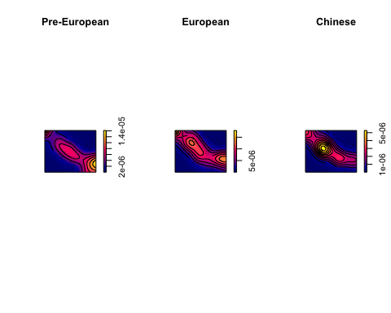

Figure 7: Kernal density map

## Spatial distribution

To examine whether the distribution of ornament is uneven that could reflect the presence of social inequality, point pattern analysis is used to examine the distribution. Point pattern analysis is a way to assess whether the distribution of sites or artifacts represent some “hotspots” that imply social processes (Bevan and Lake, 2016; Ducke, 2015), and in this case the pattern of ornaments could be able to indicate the changes due to culture contact. The location where ornaments from were square-based recorded, thus the intensity approach was used that focuses on the average density of points across space to explore their distribution. Points were be randomly assigned to each square according to the frequency data. Next is to subset three groups for three time periods, and then compute the kernal density for each time period for comparison. Kernal density estimations (KDE) can estimate the probability of the density of events across space by creating a continuous, smooth density surface across space. Here we use KDE to visualize the event of the presence of ornaments that were represented by maps on which we are able to see core areas and surrounding neighborhoods (Bonnier et al., 2019; Cortegoso et al., 2016). Density value is assigned to each cell, of which the unit is meter. The results 7 show that there is one major core area during the pre-European contact period, multiple core areas during European contact period, and a single core during the Chinese contact period. Those maps present three consistent sub-region with shifting core area over time. The distribution might indicate different social groups who possessed more ornaments, and the multiple groups during European contact period might reflect some presence of unequal consumption. However, the generation of core areas might be biased due to small sample size, for example, a few ornaments found at one single square during the Chinese period could create obvious hot spot. To further evaluate the pattern, we test the hypothesis that whether the distribution of ornaments is randomly distributed to understand the underlying social indication related to ornaments.

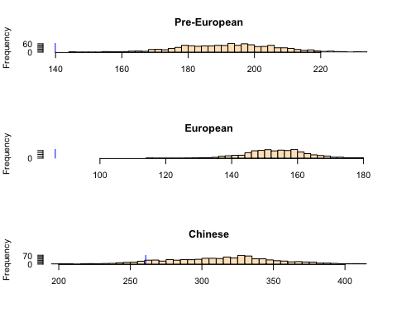

Figure 8: Histogram of simulated ANN values

Here we use Monte Carlo method to test the complete spatial randomness of spatial events based on the average nearest-neighbor distance method (ANN). We hypothesize that the distribution of ornaments is consistent with a completely random process, and then simulate the presence of ornaments across the space for one thousand times for each time periods. The data was compared to the random pattern generated by simulated processes to see if our data is randomly distributed or not. The results 8 are represented by histogram showing one thousand simulation with the blue line indicating our observed value. The results show that 100% of the simulated values are much more greater than our observed ANN value during the European contact period, which means the ornaments are clustered distributed. Similar result is also observed during the pre-European period but less extreme. The distribution of ornaments is more random during the Chinese contact period and about one third of the simulated values are greater than our observed ANN value. This testing explains that the distribution of ornaments during the pre-European and European contact period might reflect the presence of different social groups. Moreover, the cluster of ornaments way more significant during the European contact period that might indicate some extent of control of ornaments.

# Discussion

The introduction of ornaments to Northeastern Taiwan during different periods could inform how local indigenous people perceive and distribute the trading goods in different contexts of culture contacts by examining their frequency and spatial distribution across space. Taiwan island had been involved in regional exchange networks of Southeast Asia since Neolithic period, a global trade network during the European contact period in the early 17th century, and later intense but smaller scale network with Han Chinese communities since 19th century (Chen, 2005). Kiwulan demonstrates continuous occupation covers those episode of culture contacts that enables a comparative research to explore the indirect influence of culture contact especially in the global colonial context by examining prestige goods. These three analytic chronology at Kiwulan represent different scale of exchange network and intensity of culture contact. For the scale of trade network, Pre-European contact can be defined as a middle scale represented by the prehistoric regional trade network in Southeast Asia. International trade network during the European contact presents a global scale, while local trade network during the Chinese contact presents a small scale. For the intensity of culture contact, both pre-European contact and European contact period could be defined as indirect contact, but the colonial power underlying the contact with the Europeans should be also considered. The culture contact during the Chinese period is more direct due to the migration of Han Chinese to Kiwulan.

The results show there was a greater diversity of ornaments types and materials at Kiwulan during European contact. This might result from the large scale exchange network that stimulate the circulation of different ornaments classes. Among those ornaments, agate beads and metal rings have greater quantity and variety of shapes compared to copper bell and glass beads, which might indicate the diverse origins. However, the frequency of overall ornaments and each subtype declines significantly during the Chinese contact period. The reason could be related to smaller scale of network and the overall decline of Kiwulan population at that time. The spatial pattern of ornaments shows that there were some clusters appeared since pre-European and European contact period. The hypothesis testing for spatial pattern further indicate more concentration of ornaments during European contact. Because trade ornaments had been viewed as prestige goods in local cultural context in the prehistoric Northeastern Taiwan, this differentiation could reflect some level of social inequality appeared before European contact and then it was reinforced during European period.

# Conclusion

Indirect influence of colonialism has been proposed recently and some studies reveal how peripheral areas had been influenced by the colonial activities or involved in the colonial economy centered in the major European colonies (Trabert, 2017). Kiwulan in Northeastern Taiwan is an especially important case study where the location was relatively isolated and peripheral that can provide valuable insight into the discussion of influence of indirect colonial contacts. Foreign trade ornaments were viewed as prestige goods and played an important role in the cultural context of indigenous societies in northeastern Taiwan according to the use context as grave goods and historical documents written by foreign record keeper. As a marker for status, the frequency and spatial distribution of body ornaments at Kiwulan present three distinct patterns during different culture contact periods. Greater amount and diversity ornament types during the European contact period reflects the international stimulation of exchange in a colonial context. Those ornaments may convey different meaning with exotic and colonizer image that increases more competitions between aggrandized individuals for prestige and wealth accumulation, which might result in a increasing social inequality. The spatial pattern of ornaments at Kiwulan during European contact presents multiple clusters that is significantly different from a random distribution pattern. This study demonstrates that foreign trade ornaments could be a proxy to detect the indirect colonial influence on local indigenous populations and give insights into the emergence of social inequality stimulated by the European colonization. It also shows the agency of indigenous people to incorporate and recontextualize the ornaments into their culture system. During the Chinese contact period, the decreasing frequency and diversity of ornaments showing a decline in the production, use and discard of ornaments at Kiwulan, which might be related to the smaller scale of exchange network with limited sources of ornaments or the overall decline of Kiwalan population. This is a case study that focuses on trade ornaments and more studies can be done to include other trade goods like porcelains. Also, further studies to explore the extent of social inequality and the shift in social organization could be conducted by examining multiple line of evidence from Kiwulan, including pottery production and mortuary practices. # Acknowledgements

##### pagebreak

# References

Andrade, T., 2007. How Taiwan became chinese : Dutch, spanish, and han colonization in the seventeenth century. Columbia University Press, New York.

Bellina, B., 2014. Maritime silk roads’ ornament industries: Socio-political practices and cultural transfers in the south china sea. Cambridge Archaeological Journal 24, 345–377.

Berrocal, M.C., Herrero, E.S., Moret, M.G., González, A.U., Pérez, M.T., Rodrı'guez, S.C., Chevalier, A., Valentin, F., Tsang, C.-h., 2018. A comprised archaeological history of taiwan through the long-term record of heping dao, keelung. International Journal of Historical Archaeology 22, 905–940.

Bevan, A., Lake, M., 2016. Intensities, interactions, and uncertainties: Some new approaches to archaeological distributions, in: Bevan, A., Lake, M. (Eds.), Computational Approaches to Archaeological Spaces. Routledge, pp. 27–52.

Blussé, L., Everts, N., 2000. (FEII) the formosan encounter. Notes on formosa’s aboriginal society, a selection of documents from dutch archival sources. Volume ii: 1636-1645. Shung Ye Museum of Formosan Aborigines, Taipei, Taipei.

Bonnier, A., Finné, M., Weiberg, E., 2019. Examining land-use through gis-based kernel density estimation: A re-evaluation of legacy data from the berbati-limnes survey. Journal of Field Archaeology 44, 70–83.

Borao, H., J. E., 2001. (SIT, pp. 1-343). Spaniards in taiwan, vol. I (1582–1641). SMC Publishing, Taipei.

Borao, J.E., 2009. The spanish experience in Taiwan, 1626-1642: The baroque ending of a renaissance endeavor. Hong Kong University Press, Hong Kong.

Carter, A.K., 2016. The production and exchange of glass and stone beads in southeast asia from 500 bce to the early second millennium ce: An assessment of the work of peter francis in light of recent research. Archaeological Research in Asia 6, 16–29.

Chen, S., n.d. Kavalan ting zhi [kavalen culture history], taiwan wen xian cong kan di 106 zhong [taiwan literature series: 106]. Economic Research Office, Bank ofTaiwan, Taipei.

Chen, T.-j., 2005. Ji long shan yu dan shui yang : Dong ya hai yu yu tai wan zao qi yan jiu, 1400-1700 [mount keelung and tai she ocean: A study of east asian seas and the hisotry of Taiwan from 1400 to 1700]. Lian jing, Taipei.

Chen, Y.-p., 2007. Qi wu lan yi zhi qiang jiu fa jue bao gao [ report on the archaeological excavations at ki-wu-lan site]. Lanyang museum, Yilan, Taiwan.

Cheng, C.-F., 2008. Qi wu lan yi zhi yu she nei yi zhi chu tu bo li zhu de xiang guan yan jiu [studies of glass beads excavated from kivulan and shenei site, taiwan] (Master’s thesis).

Cortegoso, V., Barberena, R., Durán, V., Lucero, G., 2016. Geographic vectors of human mobility in the andes (34–36° s): Comparative analysis of ‘minor’obsidian sources. Quaternary International 422, 81–92.

Dietler, M., 2015. Archaeologies of colonialism: Consumption, entanglement, and violence in ancient mediterranean france. Univ of California Press.

Dietler, M., 2005. The archaeology of colonization and the colonization of archaeology: Theoretical challenges from an ancient mediterranean colonial encounter, in: Stein, G. (Ed.), The Archaeology of Colonial Encounters: Comparative Perspectives. NM: Sch. Am. Res. Press, Santa Fe, pp. 33–68.

Dietler, M., 1997. The iron age in mediterranean france: Colonial encounters, entanglements, and transformations. Journal of World Prehistory 11, 269–358.

Ducke, B., 2015. Spatial cluster detection in archaeology: Current theory and practice, in: Barcelo, J.A., Bogdanovic, I. (Eds.), Mathematics and Archaeology. CRC Press Boca Raton, Barcelona, Spain, pp. 352–368.

Francis, P., 2002. Asia’s maritime bead trade: 300 bc to the present. University of Hawaii Press.

Given, M., 2004. The archaeology of the colonized. Routledge, London; New York.

Hsieh, E., 2009. Yi lan qi wu lan yi zhi chu tu wai lai tao ci qi zhi xiang guan yan jiu [the study of imported ceramics excavated at the ki-wu-lan site, i-lan] (Master’s thesis).

Joyce, R.A., 2005. Archaeology of the body. Annual Review of Anthropology 34, 139–158.

Junker, L.L., 1993. Craft goods specialization and prestige goods exchange in philippine chiefdoms of the fifteenth and sixteenth centuries. Asian Perspectives 1–35.

Kang, P., 2016. Colonial imagination and local variations: The dutch east india company and the formosan austronesians. Lian-jing.

Kang, P., 2012. He lan dong yin du gong si zhi xia de ga ma lan di qu te zhi [charateristics of kavalan under colonial rule of dutch east India companies], in: Hsu, M.-C., Li, S.-Y. (Eds.), Exploring Kiwulan: The Ninth Academic Conference of Yilan Study. Institute of Yilan County History, Yilan, pp. 291–317.

Ke, P., n.d. Kavalan zhi lue [record of kavalen]. Historical Records Committee of Taiwan Provincial Government, Nantou.

Ketel, C., 2011. Identification of export porcelains from early 17th century voc shipwrecks and the linkage to their cultural identification, in: Core, D. (Ed.), The 2011 Asia-Pacific Regional Conference on Underwater Cultural Heritage Proceedings. Manila, Philippines, pp. 1–14.

Lape, P.V., 2003. A highway and a crossroads: Island southeast asia and culture contact archaeology. Archaeology in Oceania 38, 102–109.

Li, C.-y., Chiu, S.-j., 2014. A report on excavations in the yi-lang agricultural vocational high school site, 2000-2008. Field Archaeology of Taiwan 17, 59–120.

Li, Y.-z., Wu, M.-z., 2006. Qing zai xi ban ya ren zai tai wan, 1626-1642 [the spanish in Taiwan]. Taiwan Historica, Nantou.

Liu, P.-c., 2008. Identity, gender and settlement: Ritual studies of changing kavalan. Taiwan Historica, Nantou: Council of Indigenous Peoples, Executive Yuan.

Liu, Y.-c., Wang, S.-C., 2017. Encountering the wider world before the transition to history: Chinese ceramics in proto-historic taiwan (tenth through sixteenth centuries), in: Cruz Berrocal, M., Tsang, C. (Eds.), Historical Archaeology of Early Modern Colonialism in Asia-Pacific: The Southwest Pacific and Oceanian Regions. University Press of Florida, Florida, Gainesville, pp. 270–312.

Mitchell, S., 2000. "Guns or barter" indigenous exchange networks and the mediation of conflict in post-caontact western arnhem land, in: Torrence, R., Clarke, A. (Eds.), The Archaeology of Difference : Negotiating Cross-Cultural Engagements in Oceania. Routledge, London; New York, pp. 182–214.

Mullins, P.R., 2011. The archaeology of consumption. Annual Review of Anthropology 40, 133–144.

Nakamura, 1938. Overgekomen brieven en papieren. [The dutch cencus record for indigenous peoples in taiwan]. Southern Anthropological Studies 4, 12.

National Musuem of Taiwan History, A. group in, 2005. Taiwan under dutch and spanish: A report of historical archaeological research in northern taiwan. National Musuem of Taiwan History, Taipei.

Rubertone, P.E., 2000. The historical archaeology of native americans. Annual Review of Anthropology 29, 425–446.

Scaramelli, F., Scaramelli, K.T. de, 2005. The roles of material culture in the colonization of the orinoco, venezuela. Journal of Social Archaeology 5, 135–168.

Silliman, S., 2001. Agency, practical politics and the archaeology of culture contact. Journal of social archaeology 1, 190–209.

Silliman, S.W., 2005. Culture contact or colonialism? Challenges in the archaeology of native North America. American Antiquity 55–74.

Theunissen, R., Grave, P., Bailey, G., 2000. Doubts on diffusion: Challenging the assumed indian origin of iron age agate and carnelian beads in southeast Asia. World archaeology 32, 84–105.

Torrence, R., 2000. Just another trader? An archaeological perspective on european barter with admiralty islandsers, Papua New Guinea, in: Torrence, R., Clarke, A. (Eds.), The Archaeology of Difference: Negotiating Cross-Cultural Engagements in Oceania. Routledge, London; New York, pp. 104–141.

Torrence, R., Clarke, A., 2000. Negotiating difference: Practice makes theory for contemporary archaeology in Oceania, in: Torrence, R., Clarke, A. (Eds.), The Archaeology of Difference : Negotiating Cross-Cultural Engagements in Oceania. Routledge, London; New York, pp. 1–31.

Trabert, S., 2017. Considering the indirect effects of colonialism: Example from a great plains middle ground. Journal of Anthropological Archaeology 48, 17–27.

Voss, B.L., 2005. From casta to californio: Social identity and the archaeology of culture contact. American Anthropologist 107, 461–474.

Wang, L.-Y., 2011. Yi lan qi wu lan yi zhi chu tu zhuang shi pin zhi xiang guan yan jiu [a research of ornaments excavated at ki-wu-lan site, i-lan] (Master’s thesis).

Wang, S.-C., Liu, Y.-C., 2007. Shi qi shi ji qian hou tai wan yan cao , yan dou yu bo li zhu shi de shu ru wang luo -yi ge xin de jiao huan jie duan [the import networks of tobacco, tobacco pipes, and glass bead ornaments into Taiwan circa the seventeenth century: A new phase of exchange]. Taida Journal of Art History 51–83.

Yao, ying, n.d. Dong cha ji lue [record of taiwan], taiwan wen xian cong kan di 007 zhong [taiwan literature series: 007]. Taiwan Historica, Nantou.

##### pagebreak

### Colophon

This report was generated on 2019-07-09 14:49:49 using the following computational environment and dependencies:

#> ─ Session info ──────────────────────────────────────────────────────────  
#> setting value   
#> version R version 3.6.0 (2019-04-26)  
#> os macOS Sierra 10.12.6   
#> system x86_64, darwin15.6.0   
#> ui X11   
#> language (EN)   
#> collate en_US.UTF-8   
#> ctype en_US.UTF-8   
#> tz America/Los_Angeles   
#> date 2019-07-09   
#>   
#> ─ Packages ──────────────────────────────────────────────────────────────  
#> package * version date lib source   
#> abind 1.4-5 2016-07-21 [2] CRAN (R 3.6.0)  
#> assertthat 0.2.1 2019-03-21 [2] CRAN (R 3.6.0)  
#> backports 1.1.4 2019-04-10 [2] CRAN (R 3.6.0)  
#> bookdown 0.11 2019-05-28 [2] CRAN (R 3.6.0)  
#> broom 0.5.2 2019-04-07 [2] CRAN (R 3.6.0)  
#> callr 3.2.0 2019-03-15 [2] CRAN (R 3.6.0)  
#> cartography * 2.2.0 2019-02-07 [2] CRAN (R 3.6.0)  
#> cellranger 1.1.0 2016-07-27 [2] CRAN (R 3.6.0)  
#> class 7.3-15 2019-01-01 [2] CRAN (R 3.6.0)  
#> classInt 0.3-3 2019-04-26 [2] CRAN (R 3.6.0)  
#> cli 1.1.0 2019-03-19 [2] CRAN (R 3.6.0)  
#> codetools 0.2-16 2018-12-24 [2] CRAN (R 3.6.0)  
#> colorspace 1.4-1 2019-03-18 [2] CRAN (R 3.6.0)  
#> cowplot * 0.9.4 2019-01-08 [2] CRAN (R 3.6.0)  
#> crayon 1.3.4 2017-09-16 [2] CRAN (R 3.6.0)  
#> DBI 1.0.0 2018-05-02 [2] CRAN (R 3.6.0)  
#> deldir 0.1-21 2019-06-15 [2] CRAN (R 3.6.0)  
#> desc 1.2.0 2018-05-01 [2] CRAN (R 3.6.0)  
#> devtools 2.0.2 2019-04-08 [2] CRAN (R 3.6.0)  
#> digest 0.6.19 2019-05-20 [2] CRAN (R 3.6.0)  
#> dplyr * 0.8.1 2019-05-14 [2] CRAN (R 3.6.0)  
#> e1071 1.7-2 2019-06-05 [2] CRAN (R 3.6.0)  
#> ellipsis 0.2.0 2019-06-20 [2] CRAN (R 3.6.0)  
#> evaluate 0.14 2019-05-28 [2] CRAN (R 3.6.0)  
#> forcats * 0.4.0 2019-02-17 [2] CRAN (R 3.6.0)  
#> foreign 0.8-71 2018-07-20 [2] CRAN (R 3.6.0)  
#> fs 1.3.1 2019-05-06 [2] CRAN (R 3.6.0)  
#> generics 0.0.2 2018-11-29 [2] CRAN (R 3.6.0)  
#> ggplot2 * 3.2.0 2019-06-16 [2] CRAN (R 3.6.0)  
#> glue 1.3.1 2019-03-12 [2] CRAN (R 3.6.0)  
#> goftest 1.1-1 2017-04-03 [2] CRAN (R 3.6.0)  
#> gridExtra 2.3 2017-09-09 [2] CRAN (R 3.6.0)  
#> gtable 0.3.0 2019-03-25 [2] CRAN (R 3.6.0)  
#> haven 2.1.0 2019-02-19 [2] CRAN (R 3.6.0)  
#> here * 0.1 2017-05-28 [2] CRAN (R 3.6.0)  
#> highr 0.8 2019-03-20 [2] CRAN (R 3.6.0)  
#> hms 0.4.2 2018-03-10 [2] CRAN (R 3.6.0)  
#> htmltools 0.3.6 2017-04-28 [2] CRAN (R 3.6.0)  
#> httr 1.4.0 2018-12-11 [2] CRAN (R 3.6.0)  
#> jsonlite 1.6 2018-12-07 [2] CRAN (R 3.6.0)  
#> KernSmooth 2.23-15 2015-06-29 [2] CRAN (R 3.6.0)  
#> knitr 1.23 2019-05-18 [2] CRAN (R 3.6.0)  
#> labeling 0.3 2014-08-23 [2] CRAN (R 3.6.0)  
#> lattice 0.20-38 2018-11-04 [2] CRAN (R 3.6.0)  
#> lazyeval 0.2.2 2019-03-15 [2] CRAN (R 3.6.0)  
#> lubridate 1.7.4 2018-04-11 [2] CRAN (R 3.6.0)  
#> magrittr 1.5 2014-11-22 [2] CRAN (R 3.6.0)  
#> maptools * 0.9-5 2019-02-18 [2] CRAN (R 3.6.0)  
#> Matrix 1.2-17 2019-03-22 [2] CRAN (R 3.6.0)  
#> memoise 1.1.0 2017-04-21 [2] CRAN (R 3.6.0)  
#> mgcv 1.8-28 2019-03-21 [2] CRAN (R 3.6.0)  
#> modelr 0.1.4 2019-02-18 [2] CRAN (R 3.6.0)  
#> munsell 0.5.0 2018-06-12 [2] CRAN (R 3.6.0)  
#> nlme * 3.1-140 2019-05-12 [2] CRAN (R 3.6.0)  
#> pillar 1.4.1 2019-05-28 [2] CRAN (R 3.6.0)  
#> pkgbuild 1.0.3 2019-03-20 [2] CRAN (R 3.6.0)  
#> pkgconfig 2.0.2 2018-08-16 [2] CRAN (R 3.6.0)  
#> pkgload 1.0.2 2018-10-29 [2] CRAN (R 3.6.0)  
#> polyclip 1.10-0 2019-03-14 [2] CRAN (R 3.6.0)  
#> prettyunits 1.0.2 2015-07-13 [2] CRAN (R 3.6.0)  
#> processx 3.3.1 2019-05-08 [2] CRAN (R 3.6.0)  
#> ps 1.3.0 2018-12-21 [2] CRAN (R 3.6.0)  
#> purrr * 0.3.2 2019-03-15 [2] CRAN (R 3.6.0)  
#> R6 2.4.0 2019-02-14 [2] CRAN (R 3.6.0)  
#> raster * 2.9-5 2019-05-14 [2] CRAN (R 3.6.0)  
#> Rcpp 1.0.1 2019-03-17 [2] CRAN (R 3.6.0)  
#> readr * 1.3.1 2018-12-21 [2] CRAN (R 3.6.0)  
#> readxl 1.3.1 2019-03-13 [2] CRAN (R 3.6.0)  
#> remotes 2.1.0 2019-06-24 [2] CRAN (R 3.6.0)  
#> rgeos 0.4-3 2019-04-24 [2] CRAN (R 3.6.0)  
#> rlang 0.4.0 2019-06-25 [2] CRAN (R 3.6.0)  
#> rmarkdown 1.13 2019-05-22 [2] CRAN (R 3.6.0)  
#> rpart * 4.1-15 2019-04-12 [2] CRAN (R 3.6.0)  
#> rprojroot 1.3-2 2018-01-03 [2] CRAN (R 3.6.0)  
#> rstudioapi 0.10 2019-03-19 [2] CRAN (R 3.6.0)  
#> rvest 0.3.4 2019-05-15 [2] CRAN (R 3.6.0)  
#> scales 1.0.0 2018-08-09 [2] CRAN (R 3.6.0)  
#> sessioninfo 1.1.1 2018-11-05 [2] CRAN (R 3.6.0)  
#> sf * 0.7-4 2019-04-25 [2] CRAN (R 3.6.0)  
#> sp * 1.3-1 2018-06-05 [2] CRAN (R 3.6.0)  
#> spatstat * 1.60-1 2019-06-23 [2] CRAN (R 3.6.0)  
#> spatstat.data * 1.4-0 2018-10-04 [2] CRAN (R 3.6.0)  
#> spatstat.utils 1.13-0 2018-10-31 [2] CRAN (R 3.6.0)  
#> stringi 1.4.3 2019-03-12 [2] CRAN (R 3.6.0)  
#> stringr * 1.4.0 2019-02-10 [2] CRAN (R 3.6.0)  
#> tensor 1.5 2012-05-05 [2] CRAN (R 3.6.0)  
#> testthat 2.1.1 2019-04-23 [2] CRAN (R 3.6.0)  
#> tibble * 2.1.3 2019-06-06 [2] CRAN (R 3.6.0)  
#> tidyr * 0.8.3 2019-03-01 [2] CRAN (R 3.6.0)  
#> tidyselect 0.2.5 2018-10-11 [2] CRAN (R 3.6.0)  
#> tidyverse * 1.2.1 2017-11-14 [2] CRAN (R 3.6.0)  
#> units 0.6-3 2019-05-03 [2] CRAN (R 3.6.0)  
#> usethis 1.5.0 2019-04-07 [2] CRAN (R 3.6.0)  
#> viridis * 0.5.1 2018-03-29 [2] CRAN (R 3.6.0)  
#> viridisLite * 0.3.0 2018-02-01 [2] CRAN (R 3.6.0)  
#> withr 2.1.2 2018-03-15 [2] CRAN (R 3.6.0)  
#> xfun 0.8 2019-06-25 [2] CRAN (R 3.6.0)  
#> xml2 1.2.0 2018-01-24 [2] CRAN (R 3.6.0)  
#> yaml 2.2.0 2018-07-25 [2] CRAN (R 3.6.0)  
#>   
#> [1] /Users/EmilyWang/Desktop/School document/LW-Paper/kwl-ornaments-2019/renv/library/R-3.6/x86_64-apple-darwin15.6.0  
#> [2] /Library/Frameworks/R.framework/Versions/3.6/Resources/library

The current Git commit details are:

#> Local: master /Users/EmilyWang/Desktop/School document/LW-Paper/kwl-ornaments-2019  
#> Remote: master @ origin (https://github.com/LiYingWang/master.paper.git)  
#> Head: [43e4b67] 2019-07-09: revise and edit reference

Word count: 4785